Detailed Installation Instructions:
Preparation:
You're first going to want to make sure there is no risk of rain for the next day or so to do this. Besides the fact that the roof will be exposed for several hours, you cannot do mortar work in the rain. It is also best to have a raw foam cushion pad with no cloth cover to sit on while doing this work. Comfort is only a minor issue. It will help keep the roof from getting chaffed, but more importantly it will be an added safety measure for you. You may need some spare roofing shingles to replace some that might get damaged in the process of replacing the step-flashing.
Recommended Tools:
You don't want to run around finding things last minute, so before you start you should have on hand: foam cushion pad, a cat's paw or a flat blade screwdriver, an air filter face mask, safety glasses, a 7.25" diamond blade on a circular saw, a broom, a brush, pressurized air w/blow nozzle, tin snips, ice pick, hammer, box cutter w/hook blade, spray bottle, bucket, mortar, garden hose, 4" wide trowel, a thin 1/2" wide mortar trowel, wire brush, and muriatic acid for clean up.
(a) Use the cat's paw, small crow bar, or a flat blade screw driver to pull the nails or staples up holding the shingles that are close to the chimney to remove the old step-flashing pieces. You should not have to force the pieces out if all the nails had been removed. They should just slide out.

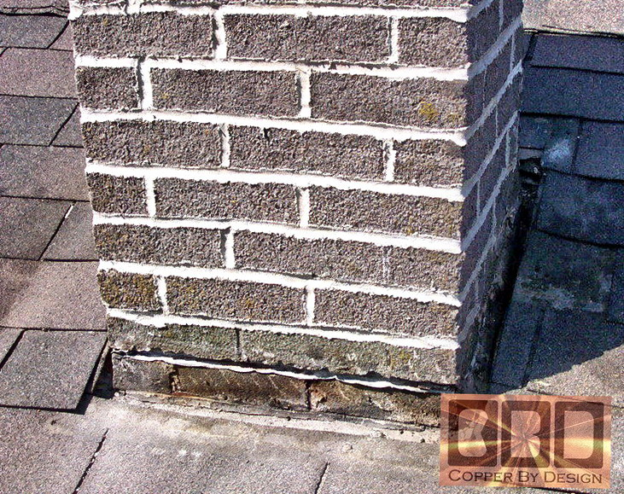

(b) Once you have that all cleared out of the way you will need to grind out the mortar where the old flashing is. I use a 7.25" diamond blade on a circular saw. I have the flat base plate removed to get in closer to the groves near the roof. It is important to wear a air filter face mask during this process. You do not want to breath in that mortar dust. Your hair will be caked with that dust and feel grimier than ever before, so you may want to wear a bandana, but it easily washes out in the shower after you're done. Do your best to grind above and below the old flashing to be able to remove it, but do your best not to remove brick material. If it is in deep that may be hard to do, but it is not recommended to grind deeper than 2" or so or you risk compromising the structural strength of the chimney before you can get the new flashing mortared back in. I have never had a chimney collapse on me from a hundred reflashing jobs, but I imagine it could happen. It is important to only cut into the horizontal mortar joints. Never cut diagonally into the bricks, or you risk creating a fracture line in the event of an Earthquake.

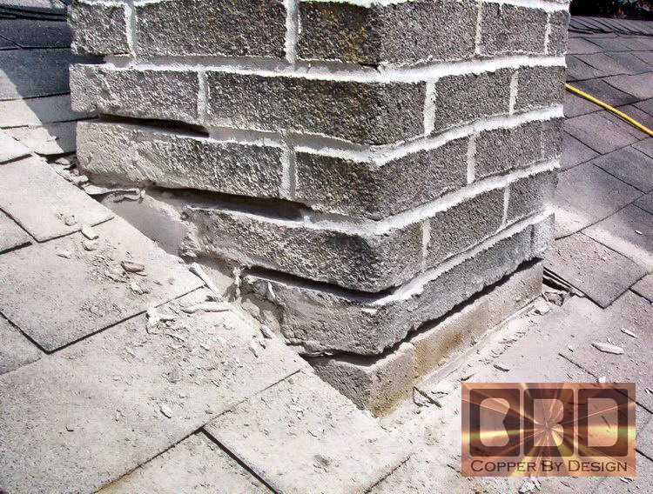

c) You'll want to clean up the area from all the loose particles and dust with a broom. It is important to keep the work area clean for safety as well. This mortar dust can make the roof feel very slippery. You'll need to blow out the groves you had just cleared out, so they are as clean as possible of loose debris. A water hose would make easy work of this, but of course you would drive gallons of water down into your attic now that the flashing is gone, so that's not an option. I use an air hose blow nozzle, but you could blow into the groves with your mouth. You will need to turn away quickly to avoid taking this dust into your lungs.
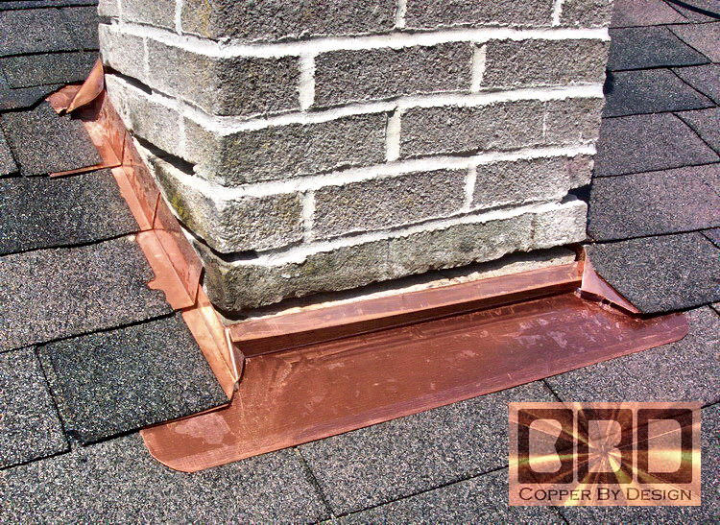
(d) You will then need to attach the step-flashing with the copper nails. You will need to start at the bottom and work your way up the sides before you can put the upper flashing in place. All roofing is designed around the idea to hide the fasteners from exposure to the elements, so it is best not to place any nails where they will be seen or exposed. The bottom step flashing should not need any nails across the bottom edge. If it does not lay nice and flat you can tweak that bend a little, so it does lay flat on the roofing along that bottom edge. It should only need nails on the sides that will be covered by the side step-flashing. When you put the nail through the side step flashing you will be going through 2 layers of copper from the flashing piece below it, so you may want to have a tool like an ice pick to help punch that hole first, or it will bend the nail driving it through both sheets, since these copper nails are softer than steel nails. As you go; cover the side and top flashing back up with the roofing shingles that you had removed, or some new shingles. Very little of the side flashing that lays on the roof should show once your done, but most of the bottom flashing will remain visible. Most of the upper flashing should be covered, but it is best to leave the lower 2" just above the bend exposed, so you may need to trim off the bottom edge of the shingles for that. If you have an upper saddle going in you will want to cover most all of the flange that lays flat on the roof with shingles to overlap into this pan, but the rise will not be covered at all. Just a few nails will be needed near the top edge of the flange that lays flat against the roof.

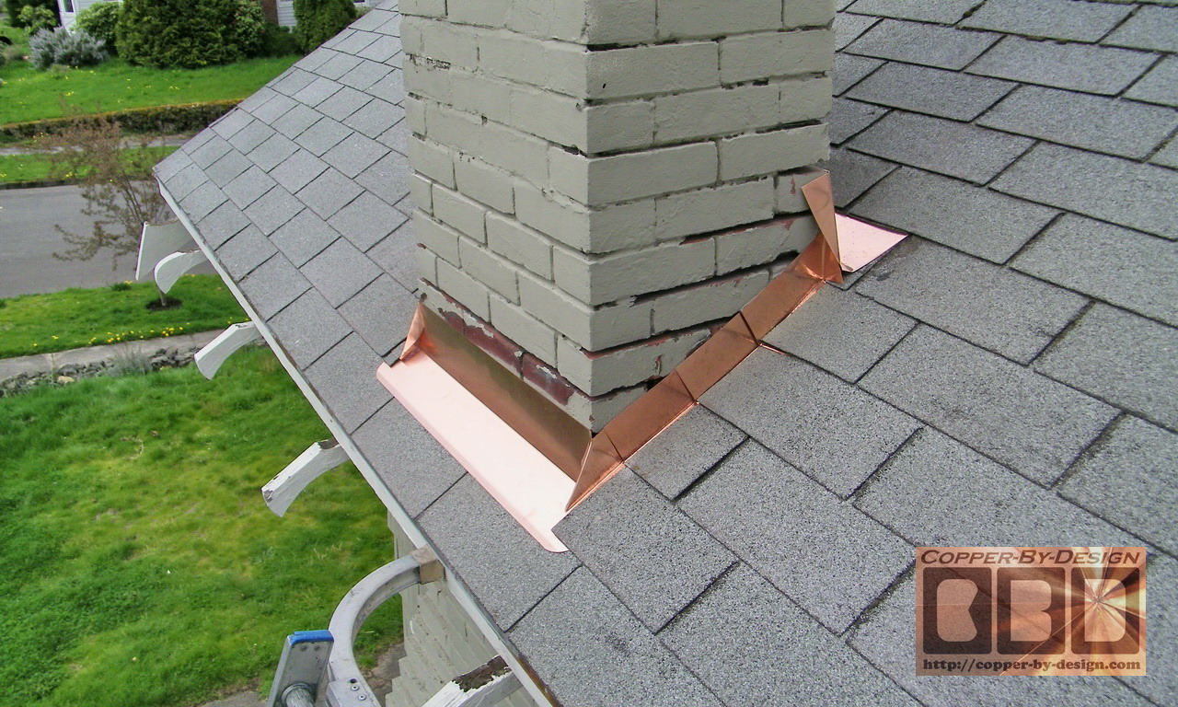

(e) You may want to add a little caulk in the corners to help seal them together, but if it is flashed right it should not be needed. There should be some copper from the upper flashing to be bent over the corners to seal them. I included some clear caulk in a small suringe.
(f) You will then need to test fit all the counter-flashing pieces in the groves and make any alterations that may be needed. You will not have time to do that after you've mixed up a batch of mortar.
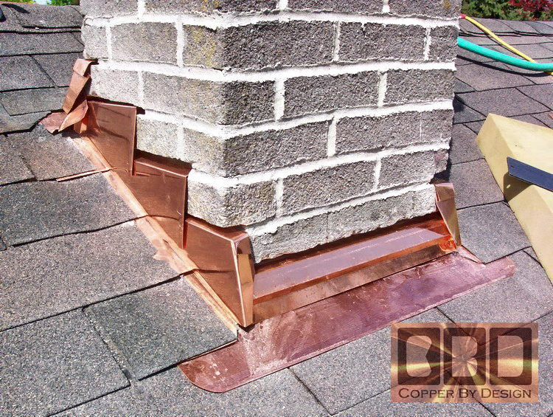
(g) You can then mix up a batch of mortar. You will need a larger and narrow trowel to quickly shove the mortar in one grove at a time and have that counter-flashing piece close by and ready to shove in as soon as possible, before you stuff mortar into the next grove. If it is a hot dry day you may even need to use a spray bottle to spritz some water in the grove before shoving the mortar in, so the mortar does not stiffen up before you can get that piece of flashing in. especially with the long bottom piece. You may even need to tap it in with a rubber mallet, so have that tool close by as well. Starting with the lowest piece and working your way up the sides it will be all you can do to get the longer pieces in before the mortar begins to set up. No screws or nails should be needed to hold the counter-flashing in place. Try to clean up the excess mortar as your go, so it is not as hard to do the clean-up later after it has dried.
(h) Once you have the last piece in you can use a short bristle brush or wire brush to clean off the excess mortar, so it is flush with the bricks. It should be fairly stiff by then if you start with the lower areas. In about an hour after getting the last counter-flashing piece in you can use the garden hose to gently spray out the messy mortar that has collected on the roof. Try to keep from spraying the new mortar you put in the groves directly. If you can handle the strong smell some diluted muriatic acid can be used to clean off the mortar smears. Hose off the left over dust down off the roof. There may be dust settled even 10' to the sides of the chimney that can be hosed off. Clean out the gutters and put all your gear away.

